Classification, how to put out and separate garbage of Tsuyama-city
★Please bring the garbage by 8:00 in the morning of a collection day
2016.6.29
classification | collection day | the garbage you can throw out | specific example
combustible waste | weekly  □ ＭＯＮ  □ ＴＵＥ  □ ＷＥＤ  □ ＴＨＵ  □ ＦＲＩ | garbage,  wastepaper,  rag,  Small piece of wood, ash,  plastics,  rubber,  hides,  plastic kind,  etcetera | 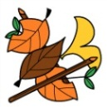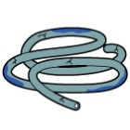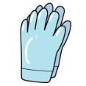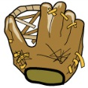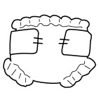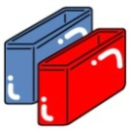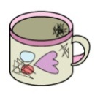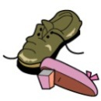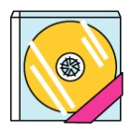  shoes  plastic case  Cup made by plastic  paper diaper  rubber glove  rubber hose  fallen leaf  garbage  ＣＤ・ＣＤ case  globe  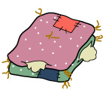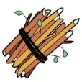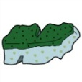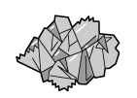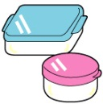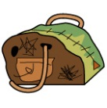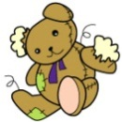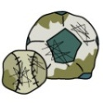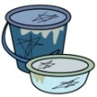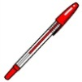  plastic container  ball‐point pen  plastic bucket  stuffed toy  cushion  Small piece of wood  ball  bag  wastepaper  sponge
 |  |  | Point to notice | ●Garbage cuts water well. ●The paper diaper removes filth. ●Cut a tree, the bamboo in 50cm or less.  ●The ash: moistens it with water, and enter the strong bag, and display it with "灰(ash)", and, please start it with one bag of less than 10 kg. ●PET bottle is “Recyclable waste”.  Ceramics (せともの)
non-burnable refuse | monthly  the  week  □ ＭＯＮ  □ ＴＵＥ  □ ＷＥＤ  □ ＴＨＵ  □ ＦＲＩ | Glass  Ceramics  metal  etcetera | 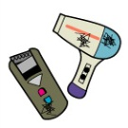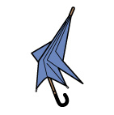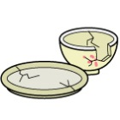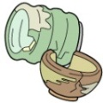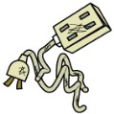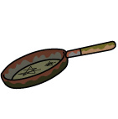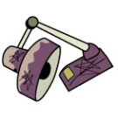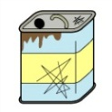  18 liter metal can  desk lamp  pan  electrical cord  Household electrical appliance (small size)  Plate (ceramics)  umbrella  Flowerpot (ceramics)  Toy (metal)  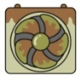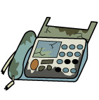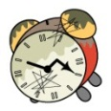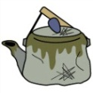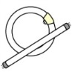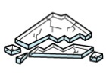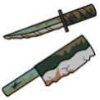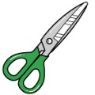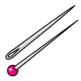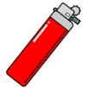  broken fluorescent lamp  Danger  Attention : Use up gas  ignitor  needle  Knife, Kitchen knife  glass  kettle  scuttle fan  Telephone, FAX  scissors  clock
 |  |  | Point to notice | ●Please never put a spray can and the cassette-type gas bomb  ●Please take out a can, a bottle, the plastic bottle to " Recyclable waste " (except the thing that the dirt does not come off)  ●Because the blades of a piece and the razor of the glass are danger, wrap it in paper take care and secure the safety  plastic bag
Container packing of plastic | □ ＭＯＮ  □ ＴＵＥ  □ ＷＥＤ  □ ＴＨＵ  □ ＦＲＩ  other than a collection of non-burnable refuse day | Container packing made by plastic  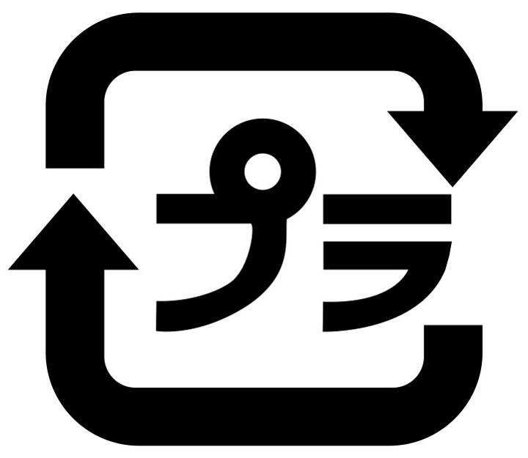  this mark is printed  on plastic goods | 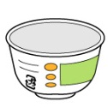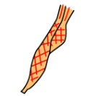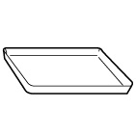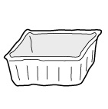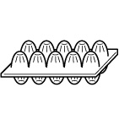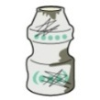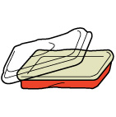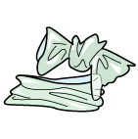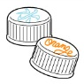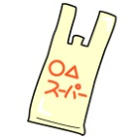  Net bags such as the fruit bag  Bottle of the edible fat oil  Label of the plastic bottle  detergent container  carrier bag  Cover of the plastic bottle  Container of the lunch  Container of the lactic acid beverage  Egg pack  Container packing of the food  Food tray  Container of cup noodles  made by plastic  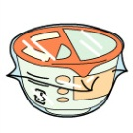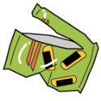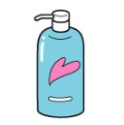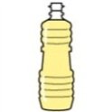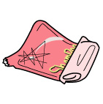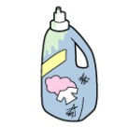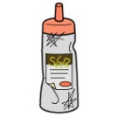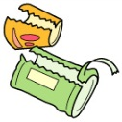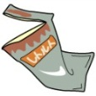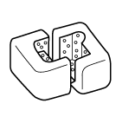  styrene foam  Retort pack  Containers such as the dressing  Refillable pouch  Shampoo container  Cake bag (plastic)  Cup noodles packing film
 |  |  | Point to notice | ●Rinse it out lightly, and, please remove dirts of the inside. Please take out the thing that a dirt of the inside does not come off to "combustible waste "  ●Please take out the product made by plastic to " combustible waste " without putting it
Recyclable waste | monthly  the  week  □ ＭＯＮ  □ ＴＵＥ  □ ＷＥＤ  □ ＴＨＵ  □ ＦＲＩ | Cans, bottles  for eating and drinking charges  （Include a spray can）  PET bottle  Fluorescent lamp・dry cell ・  Mercury-type thermometer | 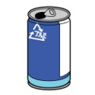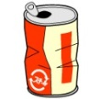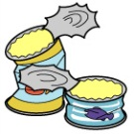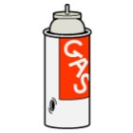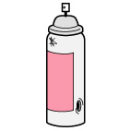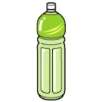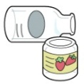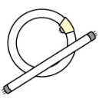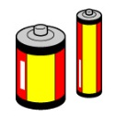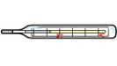  dry cell  Fluorescent lamp  Bottle (food, drink)  steel can  Danger  PET bottle  Cassette-type gas bombベ  Can of the canned food  Aluminum can  mercury-type  thermometer  spray-can
 |  |  | Point to notice | ●Please put the can, bottle, fluorescent lamp, dry cell, mercury type thermometer in the blue basket of the garbage station  ●Please put the plastic bottle in a blue net bag of the garbage station.  ●Because there is the risk of the explosion, please bring the spray can, cassette type gas bomb after using it up by all means  ●A can, a bottle, the plastic bottle, please rinse out the inside lightly  Child service playground equipment
big refuse | sometimes  Picking up at his house  or  Direct carry-on  to the clean center | Household appliances  Fitting  Kitchen articles  Vehicles  etcetera | 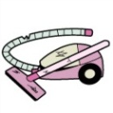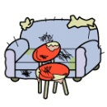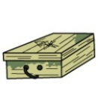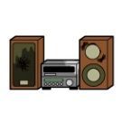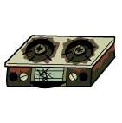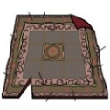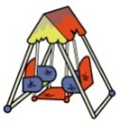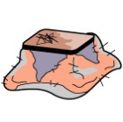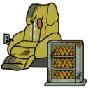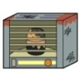  Household electrical appliance (large size)  audio instrument  gas range  carpet rag  Kotatsu  stove  ItemBox  Chair, sofa  cleaner  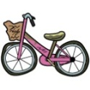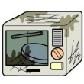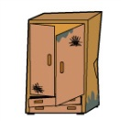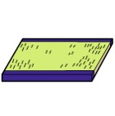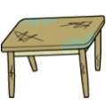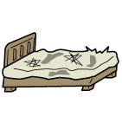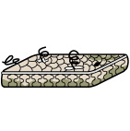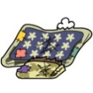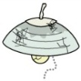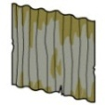  galvanized iron  lighting equipment  Spring mat  bed  tatami mat  Furniture such as chests  microwave oven  comforter  Desk, table  bicycle
 |  |  | Point to notice | ●The thing which is bigger than canned 18 liters (24cm *24cm *35cm) becomes " big refuse "
★Please bring wastepaper, Kofu(old clothes) to the recycle plaza, on a group collection day.
A city does not collect it | business-related garbage  A city do not collect the garbage pro-business to go out of a store, a restaurant, an office, the factory. You carry it in directly, or, please depend on a permission supplier. | Industrial waste Please take advice from an industrial waste disposal operator about the construction scrap wood an industrial waste supplier.  Please take advice from JA, the store you bought, about the material for agricultural machinery, agriculture. |  | Specific household electrical appliance  Have the store take over TV, an air-conditioner, a washing machine, clothing dryer, a refrigerator, the freezer.
 | Temporary a large quantity of garbage,  moving garbage  I carry it in to the clean center directly, or, please depend on a permission supplier. |  | Please talk with the store  car, auto parts,motorcycle (more than 50cc), tire, wheel, battery, gasoline, kerosene, waste oil, thinner, paint, pesticide, powerful drug, fire extinguisher, piano, family Buddhist altar |  | Personal computer  Recycling is required. I become a target of the small household appliance recycling (free collection box).
【contact details】 Kankyoujigyouka ☎22-8255,32-2203 Kamo-branch siminseikatuka ☎32-7031
Aba-branch tiikisinnkouka ☎32-7042 Shouboku-branch siminseikatuka ☎32-7022 Kume-branch siminseikatuka ☎32-7012

